Stacey King
Stacey started dancing lessons at the age of 3 and has performed in theatre such as the Liverpool Empire, and Her Majesty’s Theatre in London. Stacey studied both Theatre Studies and Performing Arts in college and also spent the summer of 2006 as an Entertainments Representative.

Dominic Melluish
Having first starred with TipTop at the young age of 8, Dominic quickly learnt that performing's his fate.
From Dodger to Chip he's had many great roles,
In his short career there are very few holes.
With an impressive c.v tucked under his hat,
Dominic returns to TipTop as Tommy the Cat!
"One of the best parts by far! I love pantomime,
I'd like to thank the whole cast for such a good time!".
Dominic hopes that you all enjoy the show,
Merry Christmas, Happy New Year, Miaow!

Becky Roberts
Rebecca has been performing since the age of 6 in music festivals, song and dance competitions with the Delta Academy of Performing Arts.She has had the experience of singing with the Fron and Brymbo male voice choirs as well as being a member of the Four Counties choir. She has performed in various theatre productions and pantomimes.

Mark Shenton
Mark has been a member of Tip Top since 1992. During which time he has appeared in many productions. He last appeared as Mr Briggs in Our Day Out. He loves pantomime and has played various role over the year, this being his first as Dame.

Kayleigh Strong
Kayleigh was introduced to the theatre performing with Foot Step's Dance School.. Kayleigh studied a degree in Musical Theatre at the University of Central Lancashire. Following her degree she has recently received a talent based scholarship to study Musical Theatre at The New York Film . Kayleigh hopes to be a part of many productions with Tip Top in the future.

Act One
Scene 1………………………………………..Chester
Scene 2……………………………..…………London

Act Two
Scene 1………………...……....…..Onboard Ship
Scene 2…………………………..……..Underwater

Act Three
Scene 1…...………….………Queen Rat’s Island
Scene 2……….………………….……..Back Home
Scene 3……………………..………..The Wedding

There will be two intervals of 15 minutes each

Scene Synopsis
Colin Banks
Colin first appeared on stage at the Gateway Theatre as a Scout in the annual production of Scoutabout.
From there he moved to the Little Theatre and with Chester Theatre Club gas appeared in many production including Admirable Chrichton , Salt of the Earth and Love on The Dole. He was also invited to appear in Love in Idleness at the Gateway Theatre, and has taken part in Chester Mystery Plays.

Peter Edwards
After joining Tip Top a year ago, Peter has taken part in last year’s pantomime and the summer show; although, he has performed in various other shows over many years with another theatre group and school productions. Out of all the characters he has played, Idle Jack is his favourite by far.

Phil Edwards
Phil is making his first stage appearance for several years and has been lured out of retirement by the thought of spending time in pantomime, his favourite kind of theatre. A founder member of Tip Top, he has appeared in several musicals with the company, including “La Cage Aux Folles” and “Hello Dolly!”. He has directed two plays for the company, “Our Day Out” and “The Rise and fall of Little Voice”.

Lyndsay Hardwick
Lyndsay is please to be playing Fairy Bowbells having been a member of the chorus in previous Tip Top Productions. Most recently she played Ruby in Hold Tight it’s 60’s Night and is looking forward to being the protector of Dick Whittington!

Grace Inskip
Grace has performed in a number of Tip Top shows which include pantomimes and the character of Morales in A Chorus Line. Grace studied Musical Theatre at Phil Winston’s Theatre Works and has worked for Warner Leisure Hotels in Harrogate.

Cast
(in order of appearance)

Fairy Bowbell………………..……..Grace Inskip*
Lyndsay Hardwick
Queen Rat…………………………….. Stacy King
Alice Fitzwarren…………………. Becky Roberts
Idle Jack………………………...… Peter Edwards
Captain Fitzwarren………………… Colin Banks
Sarah the Cook………………..…. Phil Edwards*
Mark Shenton
Dick Whittington……………… Kayleigh Strong
Tommy The Cat……………... Dominic Melluish
* at certain performances

Dancers
Jessica Martin, Grace Inskip, Lauren Smith, Emily Baker, Phillipa Lewis, Vicky Lewis, Becki Dwerryhouse & Lauren Roberts

Tip Top’s Forum Studio Theatre Productions

Oleanna
20th – 22nd January 2011

Shirley Valentine
3rd – 12th February 2011

Sunny Rhyl
3rd – 5th March 2011

Little Shop of Horrors
17th – 26th March 2011

Cheshire Cats
11th – 16th April 2011

Desperate to be Doris
5th – 14th May 2011

BOX OFFICE: 01244 341296
www.chestertheatre.co.uk
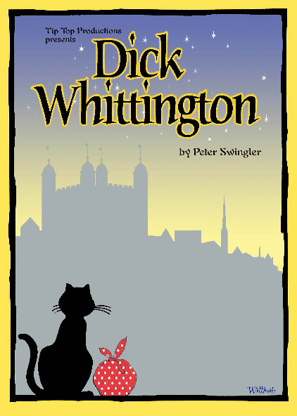
PRODUCTION TEAM

Director
Gareth Pierce

Producer
Andrew Roberts

Musical Director
David Pritchard

Choreographer
Kayleigh Melluish

Company Stage Manager
Lizzie O’Sullivan

Assistant Stage Managers
Pippa Redmayne & Dave Pearce

Lighting
Ian Jones

Sound
Paul White

Technicians
Laura Harris, John Wood & Martin Fraser

Scenery Design & Painting
Michael Willhoite

Sarah The Cooks Costumes
Mel Regan

Tip Top Productions aims to promote music, drama and theatre for all. Participation is open to anyone interested either on stage, backstage or front of house. To find out more about Tip Top, our future programme, or to be placed on our mailing list, please contact Peter Roberts at 20 Rhodfa Annwyl, Rhuddlan, LL18 2SQ or email: info@tiptoproductions.co.uk

www.tiptopproductions.co.uk

Tip Top Productions would like to thank the management and staff of The Stiwt for the help and support

ACKNOWLEDGEMENTS

Barbara Davies, Sheila Roberts, Gill Tilling & Maureen Roberts

The Tip Top Front of House team

